WEEK 8 – STUDENT PERFORMANCE ANALYSIS DASHBOARD

Varnikari g
E25da051
b.sc ds & ai
1. Introduction
In Week 8, an interactive Student Performance Analysis Dashboard was created using Microsoft Power BI. The dashboard was developed to analyze students' academic performance based on subject scores, average marks, grades, pass percentage, gender, and parental level of education.

The dashboard provides a clear and interactive way to understand student performance using different charts, cards, slicers, and visualizations.

2. Objective
The main objectives of this dashboard are:
- To analyze overall student performance.
- To compare Math, Reading, and Writing scores.
- To calculate and display the average scores.
- To analyze student grades.
- To identify the overall Pass Percentage.
- To compare performance based on gender.
- To analyze students based on parental level of education.
- To create an interactive dashboard using Power BI.

3. Dashboard Title
Student Performance Analysis Dashboard
The dashboard contains KPI cards, charts, slicers, and different visualizations to present student performance in an easy-to-understand format.

4. KPI Cards
The dashboard contains five important KPI cards:
Pass %
The dashboard displays a 97% Pass Percentage, showing the proportion of students who passed based on the defined result condition.
Average Score
The overall displayed Average Score is 69.37.
Average Math Score
The displayed Average Math Score is 63.43.
Average Reading Score
The displayed Average Reading Score is 72.41.
Average Writing Score
The displayed Average Writing Score is 72.28.
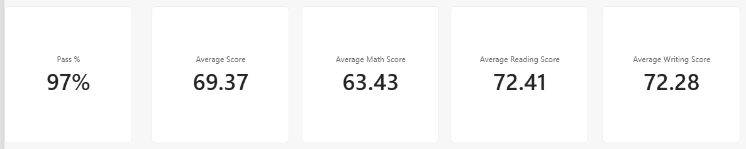
5. Subject-wise Score Analysis
A column chart was created to compare the total scores of different subjects:
- Reading Score
- Writing Score
- Math Score
The chart helps to identify the difference in performance among the three subjects.

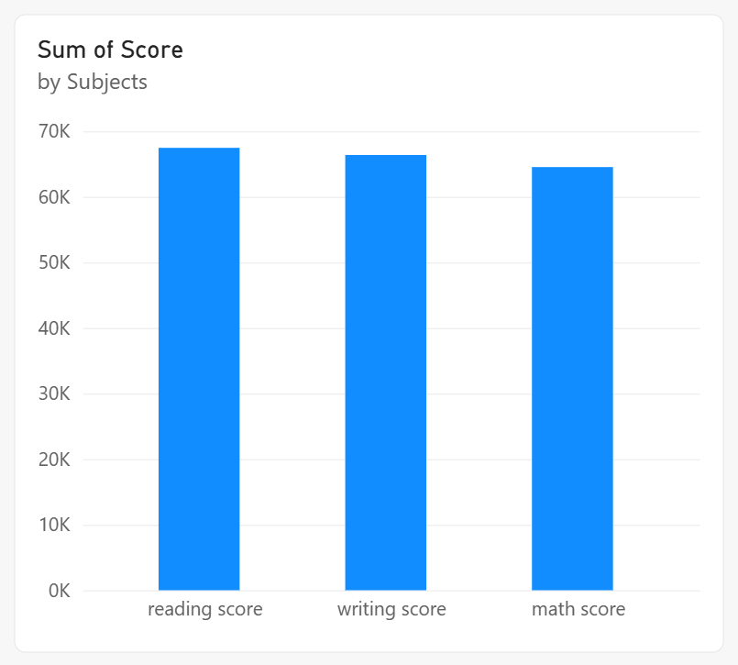
6. Gender-wise Performance Analysis
A chart was created to compare:
- Average Math Score
- Average Reading Score
- Average Score
based on gender.
This helps in understanding the difference in academic performance between male and female students.

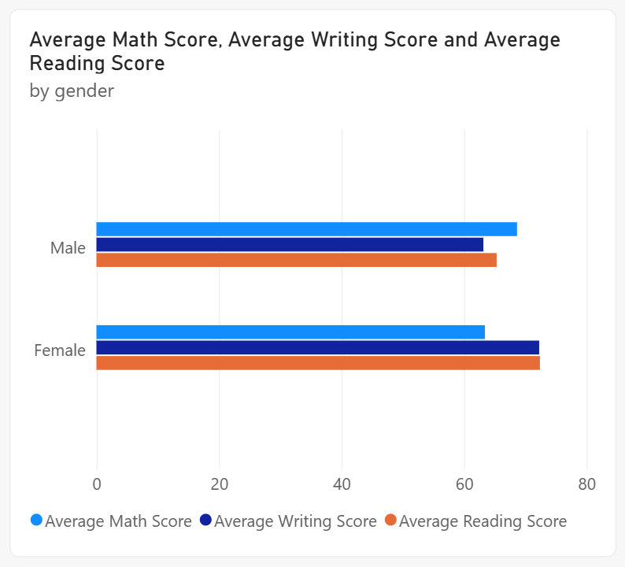
7. Grade Distribution
A donut chart was created using Grade and Student ID count.
It helps to understand how students are distributed across different grades.
The dashboard can be filtered using the Grade slicer to analyze particular grades.

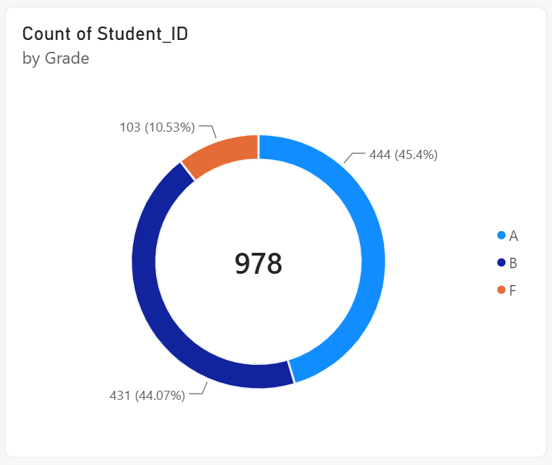
8. Gender-wise Student Count
A column chart was used to display the number of students based on gender.
This visualization helps to understand the student distribution by gender.

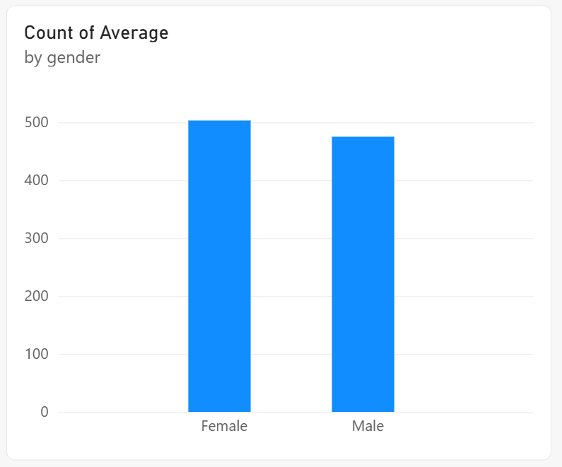

9. Subject-wise Average Score
A chart was created to compare the average scores of:
- Math
- Reading
- Writing
This provides a quick comparison of student performance across different subjects.

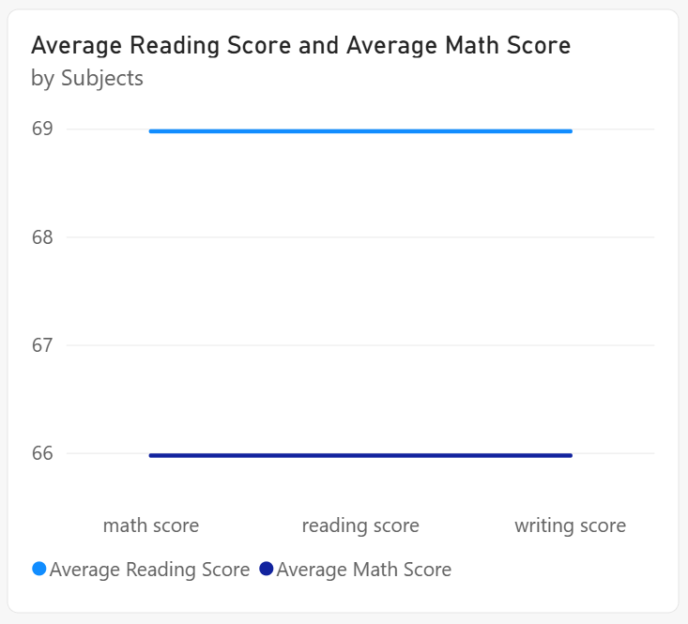

10. Pass Percentage
A Gauge Chart was used to display the Pass Percentage.
The dashboard shows a 97% Pass Percentage, providing a quick overview of student success.

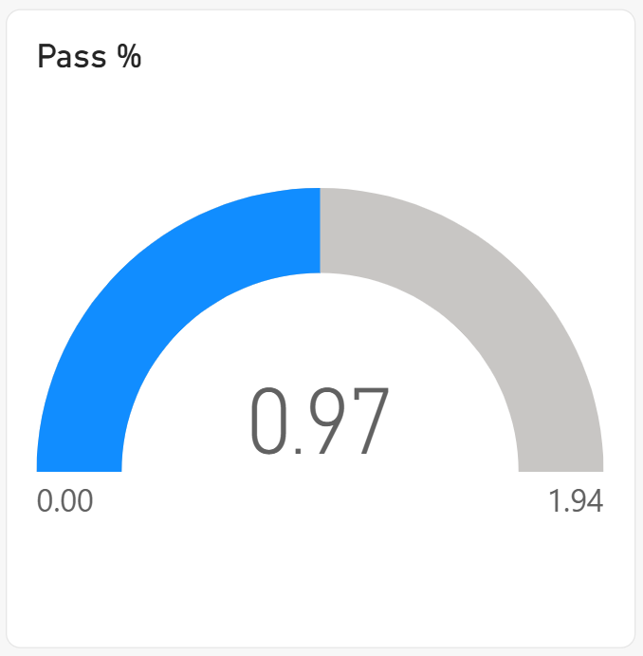

11. Average Score by Gender and Subject
A column chart was created to compare subject performance based on gender.
The chart includes:
- Math Score
- Reading Score
- Writing Score
This allows users to compare subject performance interactively.

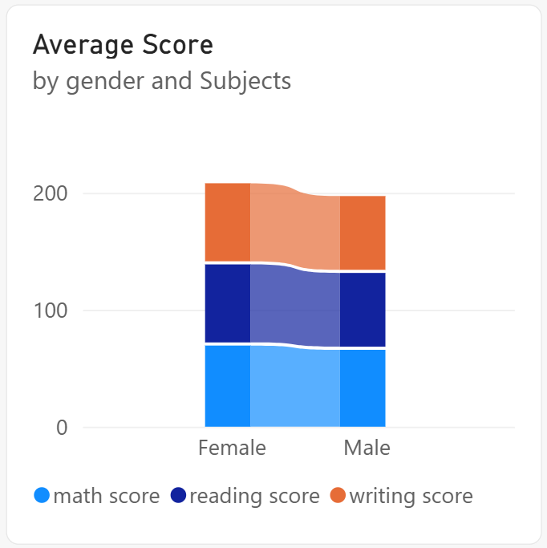
12. Parental Level of Education
A bar chart was created to show the count of students by parental level of education.
The categories include:
- Some College
- Associate's Degree
- High School
- Some High School
- Bachelor's Degree
- Master's Degree
This visualization helps analyze the distribution of students based on their parents' education levels.

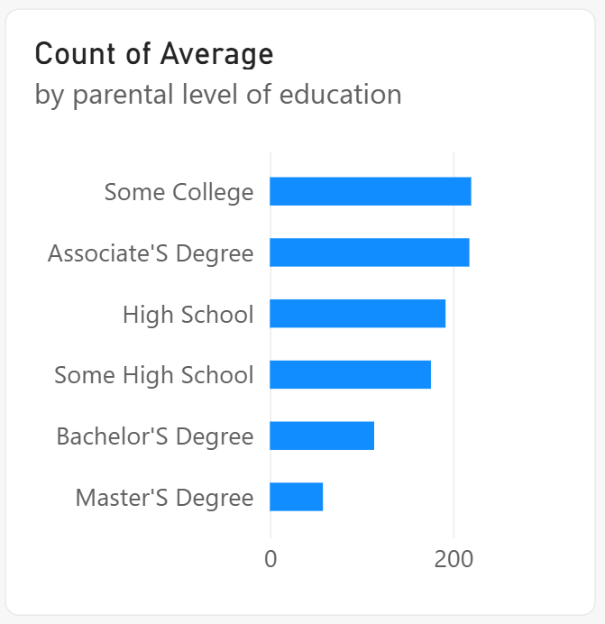
13. Slicers Used
Interactive slicers were added to the dashboard to make the analysis dynamic.
The slicers include:
- Gender
- Grade
- Lunch
- Parental Level of Education
These slicers allow users to select a particular category and analyze the dashboard based on the selected filter.

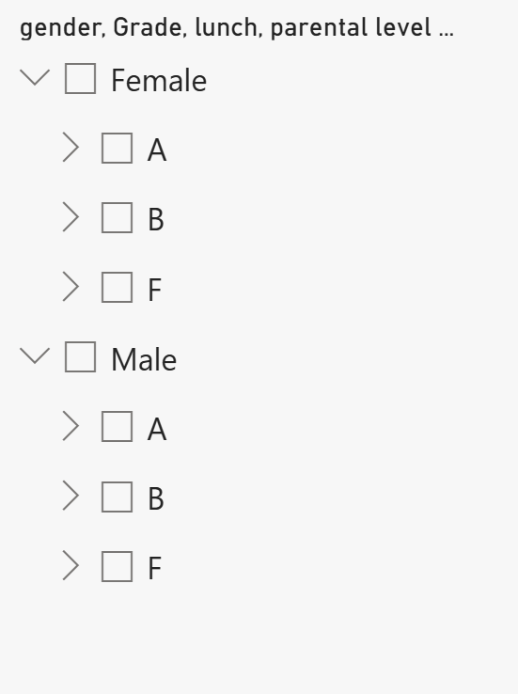

15. Conclusion
The Student Performance Analysis Dashboard was successfully created using Microsoft Power BI. Different KPI cards, column charts, bar charts, donut charts, gauge charts, and slicers were used to present student performance effectively.

The dashboard provides an interactive way to analyze scores, grades, pass percentage, gender-wise performance, subject-wise performance, and parental education levels. This Week 8 activity helped in gaining practical knowledge of Power BI visualization, dashboard design, filtering, and data analysis.

